**Ideation Phase**

**Define the Problem Statements**

|  |  |
| --- | --- |
| DATE | 19 September 2022 |
| TEAM ID | PNT2022TMID10226 |
| TEAM LEAD | AKASH |
| TEAM MEMBERS | SUNIL  SHIVA |
| PROJECT TITLE | DEVELOPING A FLIGHT DELAY PREDICTION MODEL USING MACHINE LEARNING |

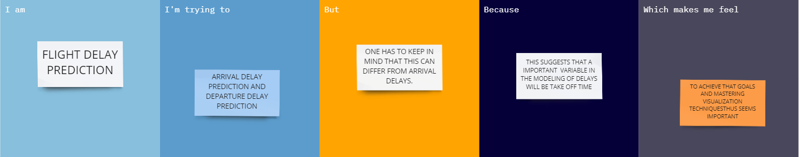

|  |  |
| --- | --- |
| **Problem Statement (PS):** | Flight delay is inevitable and it plays an important role in both profits and loss of the airlines.an accurate estimation of flights is critical for airlines because the results can be applied to increase customer satisfaction and incomes of airline agencies .there have been many researches on modelling and predicting flights delays,where most of them have been trying to predict the delay through extracting important characteristics and most related features. |
| **I am** | Flight Delay Prediction |
| **I’m trying to** | Arrival delay prediction and departure delay prediction. |
| **But** | One has to keep in mind that this can differ from arrival delays |
| **Because** | This suggests that a important variable in the modelling of delays will be take off time. |
| **Which makes me feel** | To achieve a goals and mastering visualization techniques thus seems important. |